
Student’Name
Institution of Affiliation
How silicone foam dressing compare to standards of care in preventing pressure ulcers?
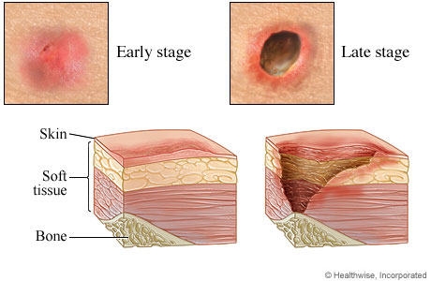
Appraisal of Research Evidence
The research articles selected as research evidence are relevant to the topic of study.
The research evidence addresses the PICOT question.
The studies add new evidence and information to the field therefore helping improve practice.
Translating Evidence into Practice
Pressure ulcers develop in patients with limited mobility especially those in intensive care unit. The research evidence shows that silicone foam dressing is effective in preventing these pressure ulcers. Healthcare settings therefore should implement this to practice to achieve positive outcomes.
Sillicone foam can reduce the likelihood of pressure ulcers by reducing the stress on tissues by the adjacent bones and an outside hard surface.
References
Lavallee, J.F., Gray, T. A., Dumville, J ., & Cullum, N. (2019). Preventing Pressure ulcers in nursing home using a care bundle: A feasibility study. Health & social care in the community, 27(4), e417-e427.

Collecting the Evidence
Where did you search for evidence: | CINAHL, PubMed
Total Electronic Search Yields | 35
Number Excluded | 32
Number Included | 3
Levels included | 1
Level 1 | 1
Level 2 | 1
Level 3 | 1
Level 4
Level 5
Level 6

Key Source of Evidence
Hahnel et al. (2020) | The study findings indicate silicone foam dressings and standard prevention practices is effective in preventing development of pressure ulcers in intensive care unit patients.
Lavallee et al. (2019) | The findings reveal that a care bundle can be effective in preventing the development of pressure ulcers.
Oe et al. (2020) | The study findings show, multilayer silicone foam dressing prevent development of pressure ulcers of the coccyx and sacrum in patients with fragile skin and severe diarrhea.

Background
Pressure ulcers develops when a soft tissue is pressed against a bony area for a long period of time. Pressure ulcers also referred to as bedsores leads to cell death, tissue necrosis and ischemia (Lavallee et al., 2019).
Pressure ulcers is a major problem in the health care system with the condition affecting patients with limited mobility such as those in intensive care unit who often spend a prolonged period in one position.
Pressure ulcers causes adverse patient outcomes contributing to discomfort, pain, anguish, loss of function, and economic hardship because of their expensive treatment (Lavallee et al., 2019).
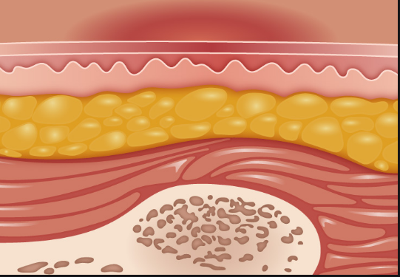
Clinical Practical Question
In intensive care patients, how does preventive silicone foam dressing compare to individual patients receiving standards of care affect the development of pressure ulcers?

